Crane Sheaves
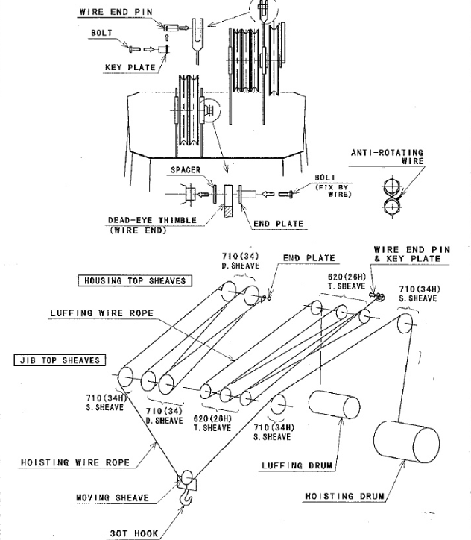
7
6
5
4
3
2
1
3 4 5 6
1 2
Crane No. 1 Housing Top Sheaves
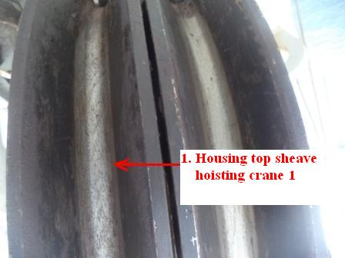 | 1) Crane No. 1 Housing Top Sheaves  Hoisting Wire: 33.5 mmØ  Wear limit: 7.0mm  Wear:
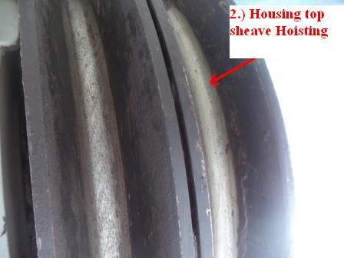 | 2) Crane No. 1 Housing Top Sheaves  Hoisting Wire: 33.5 mmØ  Wear limit: 7.0mm  Wear:
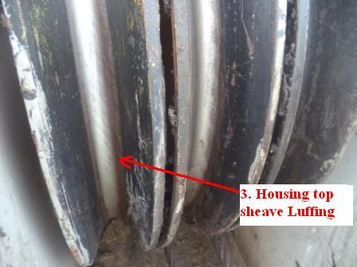 | 3) Crane No. 1 Housing Top Sheaves  Luffing wire: 25.0 mm Ø  Wear limit: 5mm  Wear:
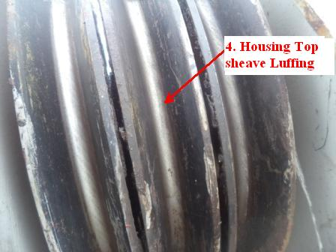 | 4) Crane No. 1 Housing Top Sheaves  Luffing wire: 25.0 mm Ø  Wear limit: 5mm  Wear:
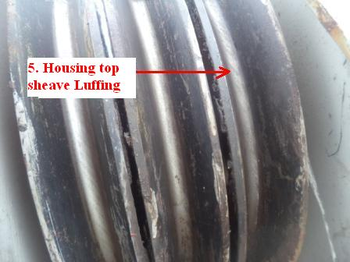 | 5) Crane No. 1 Housing Top Sheaves  Luffing wire: 25.0 mm Ø  Wear limit: 5mm  Wear:
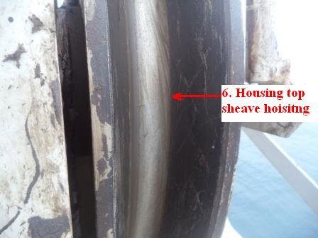 | 6) Crane No. 1 Housing Top Sheaves  Hoisting Wire: 33.5 mmØ  Wear limit: 7.0mm  Wear:

Crane No. 1 Jib Top Sheaves
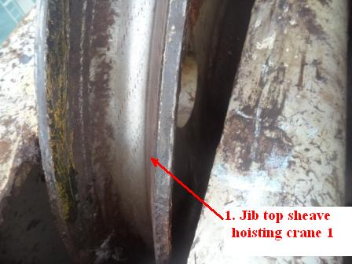 | 1) Crane No. 1 Jib Top Sheaves  Hoisting Wire: 33.5 mmØ  Wear limit: 7.0mm  Wear:
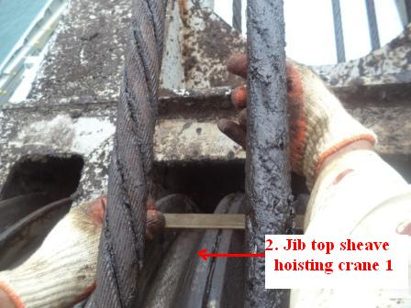 | 2) Crane No. 1 Jib Top Sheaves  Hoisting Wire: 33.5 mmØ  Wear limit: 7.0mm  Wear:
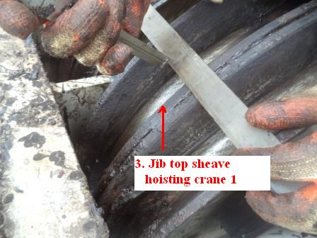 | 3) Crane No. 1 Jib Top Sheaves  Hoisting Wire: 33.5 mmØ  Wear limit: 7.0mm  Wear:
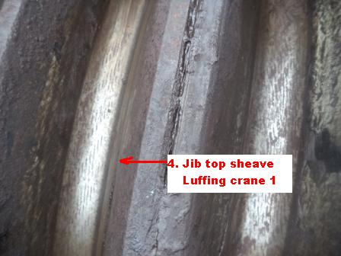 |  | 4) Crane No. 1 Jib Top Sheaves  Luffing wire: 25.0 mm Ø  Wear limit: 5mm  Wear:
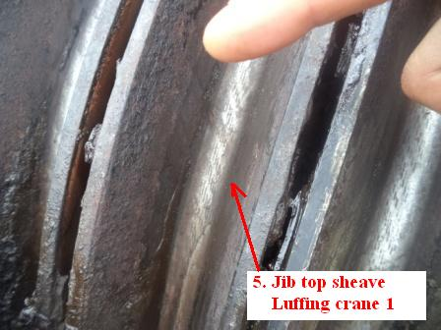 |  | 5) Crane No. 1 Jib Top Sheaves  Luffing wire: 25.0 mm Ø  Wear limit: 5mm  Wear:
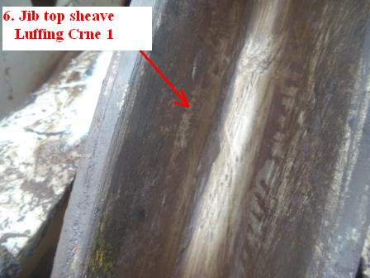 |  | 6) Crane No. 1 Jib Top Sheaves  Luffing wire: 25.0 mm Ø  Wear limit: 5mm  Wear:
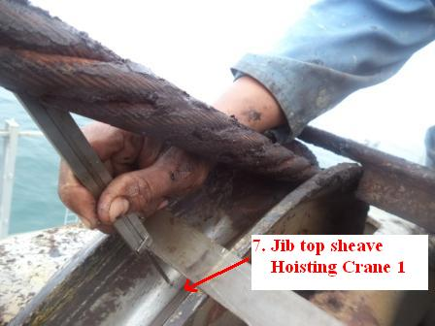 |  | 7) Crane No. 1 Jib Top Sheaves  Hoisting Wire: 33.5 mmØ  Wear limit: 7.0mm  Wear:

